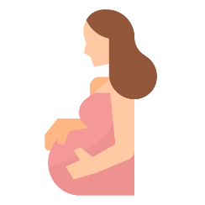

**Course: MSBA 350E – Healthcare Analytics**

**Prepared by: Diana Estefani Yehia**

**Pregnancy Health Risks**

The objective of this project is to present a dashboard to **ABAAD-Resource Center for Gender Equality**, by means of launching an awareness campaign to help women, without proper healthcare access, get proper knowledge of the many health risks that are involved during pregnancy and how to keep these risks dormant. Pregnancy symptoms and complications can range from mild and annoying discomforts to severe, sometimes life threatening, illnesses.

Many problems are mild and do not progress; however, when they do, they may harm the mother or her baby. Among the complications in pregnant women:

1. High Blood Pressure
2. Gestational Diabetes
3. Infections
4. Preeclampsia
5. Iron Deficiency Anemia
6. Depression
7. Miscarriage; which can lead to death of the mother and baby.

To avoid any complications, monitoring of the vital signs is **essential** during pregnancy. Pregnant women should have proper access to healthcare resources and visit the doctor on a monthly basis.

**Dataset Overview**

A dataset of 919 rows collected from different hospitals, community clinics; maternal health cares through the IoT based risk-monitoring system.

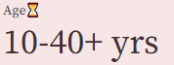

**Systolic BP:** Upper Value of Blood Pressure in mmHg

**Diastolic BP:** Lower Value of Blood Pressure in mmHg.

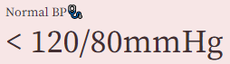

**BS:** Blood Glucose levels is in terms of molar concentration, mmol/L.

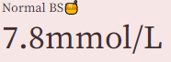

**BodyTemp:** A normal body temperature for pregnant a woman is about **37°C.**

**HeartRate:** A normal resting heart rate in beats per minute for pregnant a woman.

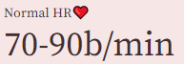

**RiskLevel:** Predicted Risk Intensity Level during pregnancy considering the previous attribute.

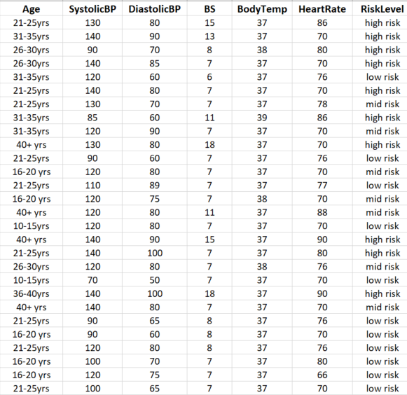

Source: <https://www.kaggle.com/datasets/csafrit2/maternal-health-risk-data>

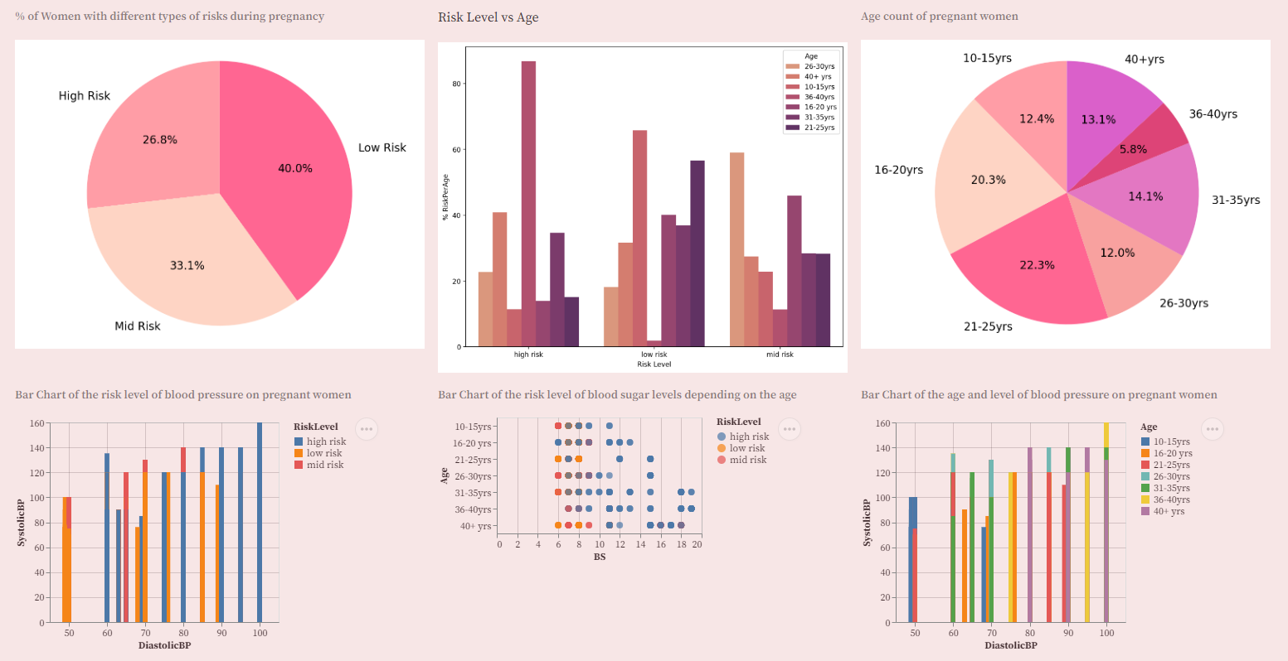

**Dashboards**

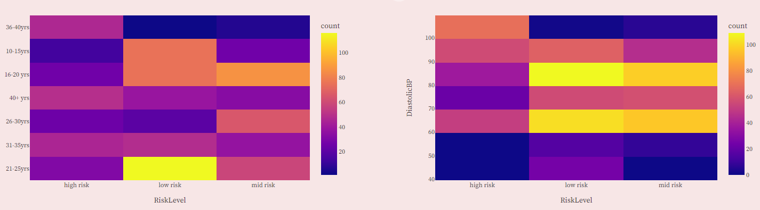

**Findings**

**High Blood Sugar Levels** (risk level: more than 10mmol/L):

* More than 140 women listed as high risk, had a blood sugar level of more than 10mmol/L.
* 110 of the women with high blood sugar levels are aged between 36 and 40+ years old.
* 86% of the women aged between 36 and 40 years and 40% of the women aged 40+ years old have higher risks during pregnancy.

A high blood sugar level can cause problems to the woman, the baby, and an increased likelihood of needing a surgery to delivery early (C-section, which is risky because it can result in external bleeding and in some cases lead to death of the baby). Babies might have higher chances to get diabetes. Thus, their blood sugar levels need to be-monitored after birth.

Women are most likely to get gestational diabetes if they are overweight, over 35, family history of type 2 diabetes, high blood sugar levels in the urine.

**Systolic Blood Pressure** (also called hypertension):

* Around 17% of the women had a systolic blood pressure of above 130mmHg of which majority were aged above 30 years old.
* People with high-risk complications had a systolic blood pressure of above 160mmHg and also a high diastolic blood pressure of 100mmHg.
* Also, we noticed that when the systolic and diastolic are close to each other (ex: 8/6, 9/7) it also imposes a high risk on pregnant women.

Hypertension can lead to pre-eclampsia which is associated with signs of damage to other organ systems including kidneys, liver, blood or brain. It can lead to serious and fatal complications to the mother and the baby. Also, it includes development of seizures. It can also lead to decreased blood flow in the placenta; the baby receives less oxygen and fewer nutrients.

**What to do?**

* Women need to be screened early for a test called the oral glucose tolerance test.
* Women need to consult with a nutritionist for a healthier diet with less sugar and carbohydrates.
* Women should do light exercise such as walking or yoga.
* Take your blood pressure medication as described.

*Researchers continue to study ways to prevent preeclampsia, but so far, no clear strategies have emerged. If you had a hypertensive disorder in a prior pregnancy, your doctor might recommend a daily low-dose aspirin (81 milligrams) beginning late in your first trimester.*

**References**

* <https://www.tandfonline.com/doi/abs/10.3109/14767058.2014.986450?journalCode=ijmf20>
* <https://health.clevelandclinic.org/cut-risk-high-blood-sugar-youre-pregnant/>
* <https://www.mayoclinic.org/healthy-lifestyle/pregnancy-week-by-week/in-depth/pregnancy/art-20046098#:~:text=High%20blood%20pressure%20during%20pregnancy%20poses%20various%20risks%2C%20including%3A,birth%20weight%20or%20premature%20birth>.
* <https://www.perinatology.com/Reference/Reference%20Ranges/Vital%20Signs.htm>
* <https://myhealth.alberta.ca/Health/Pages/conditions.aspx?hwid=uf9707>
* <https://www.ncbi.nlm.nih.gov/pmc/articles/PMC4716207/>
* <https://www.niddk.nih.gov/health-information/diabetes/diabetes-pregnancy#:~:text=High%20blood%20glucose%20levels%20during,link%20or%20a%20stillborn%20baby>.